http://www.wrapgenius.me/ food, icon

<http://emporiumpies.com/> mouse over (text -> icon) , mouse over flip 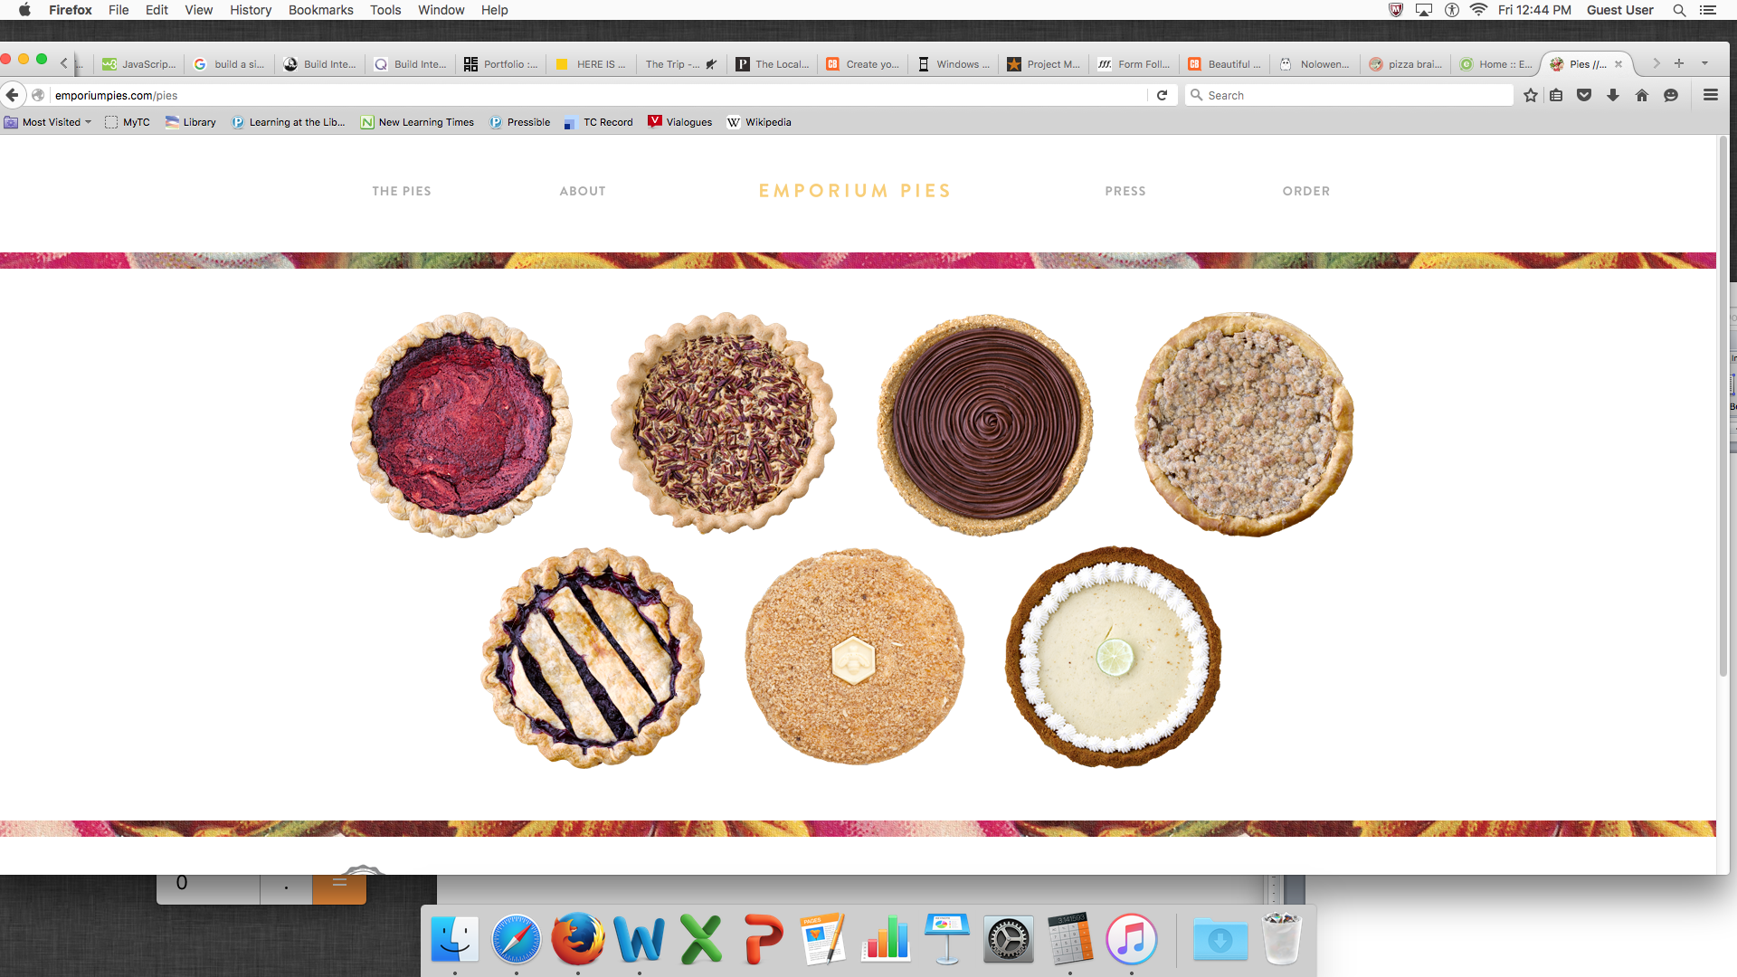

<http://thelocalpalate.com/beverages/> recipe list

<http://www.nolowenenowak.com/#home> first page layout

<http://www.jacktorrancetrip.com/background.html> interactive film

<http://mikekus.com/> grid

<http://www.choosemyplate.gov/fruitquiz> quiz

<http://www.windowsofnewyork.com> window

<https://www.supertracker.usda.gov/foodtracker.aspx> food tracker

treehouse, stretch (interface), frioto (prototype)

<https://www.caloriecount.com/calories-strawberries-i9316> nutrition fact